**FIVE GAME IDEAS**

**BY PAUL MARTE**

**Zombie Survival**

**In *Zombie Survival*, the player starts at the center of the screen, and zombies spawn randomly around the environment. The goal is to survive as long as possible by shooting the zombies that approach from all directions.**

* **Gameplay**: The player controls a character positioned at the center of the screen, able to move in all directions. The character can aim and shoot in any direction to fend off zombies that spawn randomly around the screen. The player starts with basic weapons like a pistol, and more powerful weapons randomly spawn as the game progresses.
* **Zombie Spawns**: Zombies spawn randomly at various points around the edge of the screen and move toward the player.
* **Levels and Difficulty**: The game is divided into waves of zombies, each increasing in difficulty. As the game progresses, zombies become stronger and need numerous shots to kill them.
* **Score and Time**: Players earn points for every zombie they defeat. The longer they survive, the higher their score will climb. The game tracks survival time, with each new wave adding to the challenge.
* **Goal**: The ultimate goal is to survive as long as possible while racking up points by killing zombies. Players should aim to last through multiple waves, facing increasingly difficult zombies.

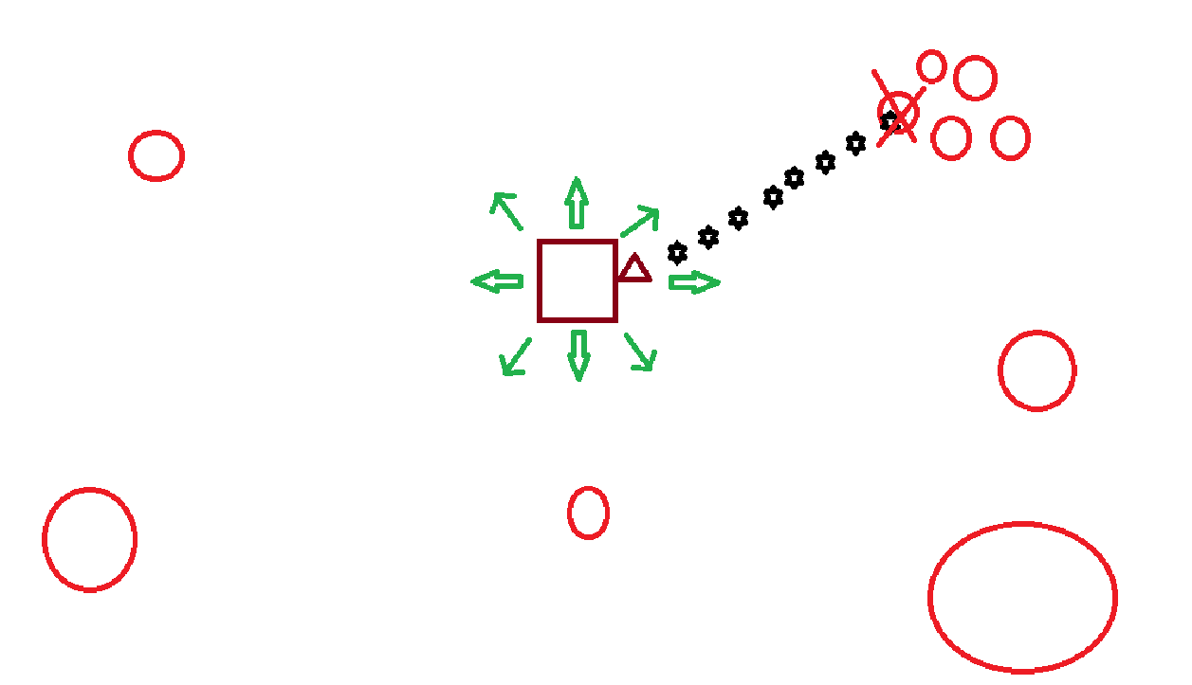

**Bank Hero**

In *Bank Hero*, the player takes on the role of a sharpshooter tasked with stopping a bank robbery. The player must avoid shooting innocent hostages or bystanders while taking down the criminals.

* **Gameplay**: The player controls a crosshair or targeting reticle on the screen. Criminals appear at random locations, and the player must quickly aim and shoot to stop them. However, innocent hostages and good people (such as bank staff or customers) are also on the scene, and the player must avoid shooting them. Each successful shot at a criminal adds to the score, but shooting a hostage or innocent person results in a penalty.
* **Hostages and Innocent People**: The hostages and good people can appear randomly, making them harder to avoid. Some may appear beside the criminal and used as human shields, so players must be extra careful when shooting.
* **Criminals**: Criminals appear at varying speeds, making them a challenge to hit. Some may take more than one shot to go down, or they may have human shields or weapons that make them harder to defeat.
* **Score and Time**: Players are awarded points for each successfully shot criminal and bonus points for clearing waves of criminals without hitting innocents. A countdown indicates how much time is left to complete.
* **Penalties**: Shooting a hostage or innocent person results in a penalty to the score, and repeated mistakes may lead to a game-over or a lower score.
* **Goal**: To eliminate as many criminals as possible while avoiding collateral damage to hostages and innocent people. Players aim to complete waves of criminals with the highest score while maintaining accuracy and careful judgment.

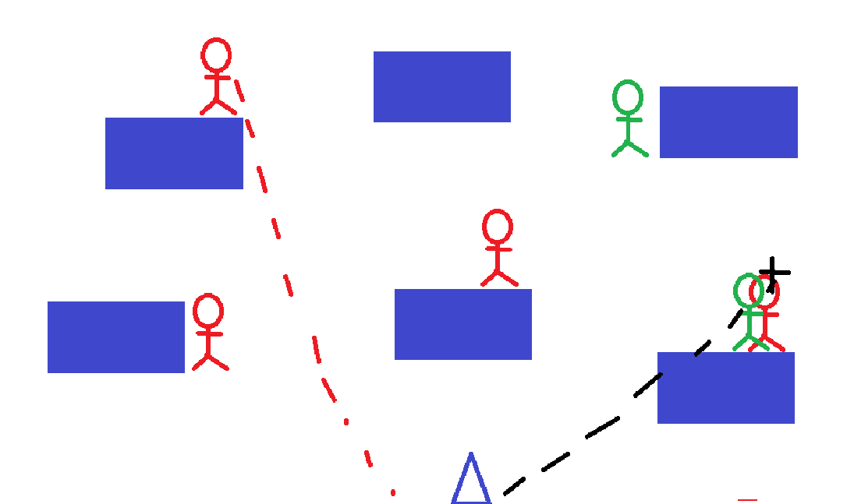

**Swat the Fly**

In *Swat the Fly*, the player takes on the role of a fly swatter, tasked with swatting flies as they buzz across the screen in a single environment (e.g., a kitchen or living room).

* **Gameplay**: Flies appear randomly on the screen, flying in unpredictable directions. The player must aim, click, or tap to swat the flies before disappearing off the screen. Each fly swatted earns points.
* **Levels and Difficulty**: As the game progresses, the flies become faster. Some flies might move in erratic patterns, making them harder to catch.
* **Score and Time**: The player has enough time to swat as many flies as possible. Every fly swatted adds to the score, while missing flies or hitting obstacles (such as other objects in the environment) results in a penalty.
* **Goal**: The goal is to accumulate the highest score by swatting as many flies as possible, progressing through levels that increase in speed and complexity as the game continues.

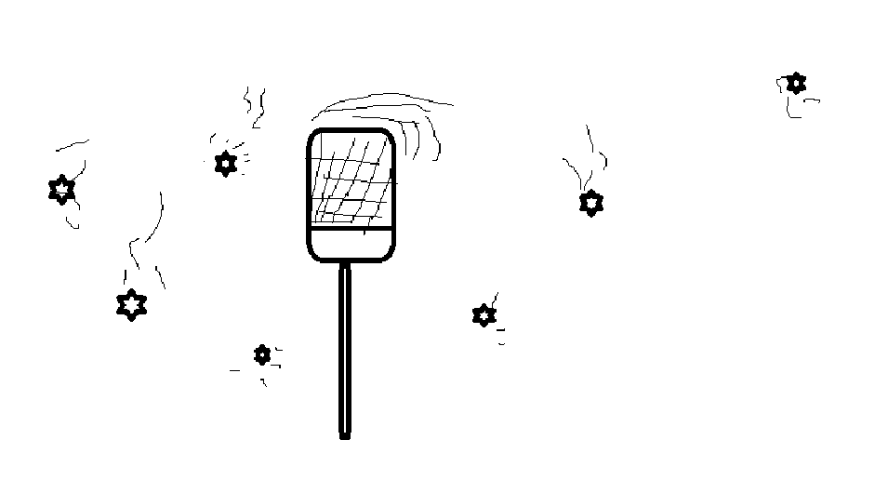

**Independence Day**

**On Independence Day, players control a spaceship that defends Earth from an alien invasion, similar to *Space Invaders*. The goal is to shoot down waves of invading alien ships while avoiding their attacks.**

* **Gameplay**: The player controls a spaceship that can move left and right along the bottom of the screen. The spaceship is armed with a basic laser cannon, which can shoot upwards to destroy incoming alien ships. Players must eliminate waves of aliens before they reach the planet.
* **Alien Invasion**: Alien ships appear in rows at the top of the screen and gradually move down toward the player. The alien ships move in a zigzag pattern and get progressively faster as the game continues. Some alien ships may fire back, adding to the challenge.
* **Levels and Difficulty**: The game is divided into multiple waves of alien attackers. As players clear each wave, the next wave features more aliens with faster movements and frequent attacks.
* **Power-ups**: Occasionally, special power-ups drop from destroyed alien ships or appear randomly during the game. These power-ups include:
  + **Rapid Fire**: Increases the firing speed of the player's weapon.
  + **Bombs**: Clears all alien ships in a specific area of the screen.
  + **Shield**: Provides temporary protection from enemy fire.
* **Score and Time**: Players are awarded points for each alien ship destroyed. The game may also include bonus points for completing waves quickly. A countdown timer may also be included, adding an extra challenge for players to clear waves within a time limit.
* **Goal**: The main goal is to defend Earth by shooting down alien ships and preventing them from reaching the bottom of the screen. Players aim to survive as long as possible while achieving the highest score possible by eliminating waves of enemies.

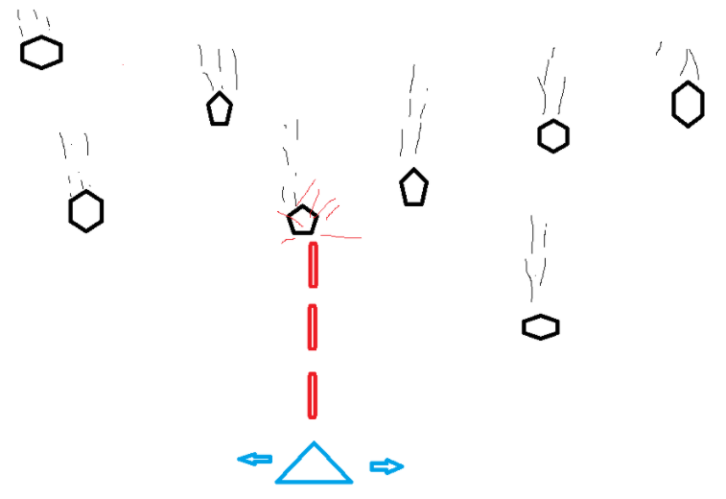

**Chicken Crossing**

In *Chicken Crossing*, the player controls a chicken trying to safely cross a busy road, inspired by *Frogger*, but with unique obstacles and challenges for added fun.

* **Gameplay**: The chicken starts at one side of the screen and must navigate across a busy road to reach the other side. The player can move the chicken up, down, left, or right to avoid traffic and obstacles. The goal is to reach the opposite side of the screen without getting hit by cars and trucks.
* **Road Obstacles**: The road is filled with moving vehicles like cars, trucks, and motorcycles that drive at different speeds. The player must time their movements carefully to avoid being run over. Some levels may introduce more challenging traffic patterns, such as faster vehicles or vehicles traveling in different directions.
* **Levels and Difficulty**: As the game progresses, the obstacles become faster and more frequent. The player may encounter new challenges, such as moving objects in the environment or multiple lanes of traffic to navigate.
* **Score and Time**: The player earns points for each successful crossing, with bonus points for completing levels quickly or without losing a life. The game keeps track of the player's best score, encouraging players to improve with each attempt.
* **Goal**: The goal is to guide the chicken across multiple levels of busy roads while avoiding obstacles and hazards. The player aims to score as many points as possible while successfully getting the chicken to the other side of each level.

